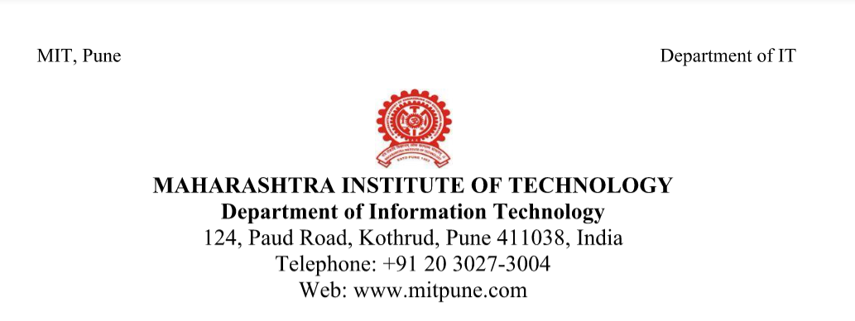

**Date: 26/02/2018**

**Roll No: 306006, 306016, 306019**

**Name: Harshali Bedmutha**

**Seminar Guide: Mrs. Himangi Pande**

**Title of the seminar: Stock market prediction system**

**Introduction:** Prediction of stock market price is one of the most important issues in finance. Many researchers have been given their idea how to forecast the market price in order to make gain using different techniques, such as technical analysis, statistical analysis, with different methods. Nowadays, artificial neural networks (ANNs) have been applied in order to predict exchange index prediction. ANN is one of data mining techniques that are learning capability of the human brain. Data patterns may perform dynamics and unpredictable because of complex financial data used. Several researches efforts have been made to improve efficiency of share values. ANNs have been used in stock market prediction during the decade.Various other techniques and algorithms like support vector algorithm (SVM) and LSTM(Long Short Term Memory) are also used.

**Motivation:**

* Since stock market is widely expanding we aim to find a predictive solution for the users.
* To reduce the difﬁculty for investors to analyze and predict market trends according to all stock market information.

**Objective:**

* To study various algorithms available for prediction of stock market
* To identify the best among all these algorithms for our project

**Brief description:**

The project aims to predict the future of stock market based on the past and present data.Prediction of stock market price is one of the most important issues in finance. Many researchers have been given their idea how to forecast the market price in order to make gain using different techniques. One common approach is to use Machine Learning algorithms to learn from price historic data to predict future prices. We aim at applying different predictive algorithms to analyse the stock market data for future trend prediction. We consider parameters like Open, High, Low, Close, Volume etc. for accurate predictions.

[Signature] [Signature]

**Student** **Seminar Guide**